### **MACEDONIAN WOMEN REGAIN CONTROL OF HOUSEHOLD EXPENSES**

Giving money to low-income households has different impacts based on the recipient of the aid. Researchers introduced some conditional cash transfers to women and some to heads of households, regardless of gender, to test the impact of gender on the spending decisions of the families. Offering conditional cash transfers to women induced households to spend a greater percentage of income on food by increasing the share of resources controlled by mothers.

**Featuring an evaluation by Alex Armand, Orazio Attanasio, Pedro Carneiro, Valerie Lechene**

**KEY RESULTS:**

**Offering conditional cash transfers to mothers increased household spending on food.** Treatment households spent more than 35% of their budgets on food, which is a 4-5% increase relative to the comparison group. Evidence also points to a marginal decrease in spending on temptation goods such as alcohol and tobacco, though the findings were not statistically significant.

**Treatment households with the lowest spending on food buy more nutritious meals.** Mothers in households with the lowest spending on food who received cash transfers bought less salt and sugar and more meat, dairy, and fish.

### **POLICY ISSUES:**

In recent decades, charities, aid programs, and NGOs have attempted to alleviate poverty in a variety of ways, key among them being providing conditional and unconditional cash transfers to individual households. However, people occupying different positions in a household spend money in various ways, and it is important to understand their inclinations in order to decide to whom the money should be transferred. Many organizations have historically targeted women as aid recipients with the belief that this will increase their control over resources, and therefore, raise their decision-making power. However, although many studies have suggested some correlation between the resources each family member contributes to the household and the subsequent allocation of total resources, there has been no comprehensive study directly tying gender to differences in household spending, much less quantifying the variation.

In 2010, there was a similar study done by Attanasio and Lechenne, which focused on the Progresa program in Mexico. Through Progresa, large conditional cash transfers were provided to women in rural Mexico, equal to almost 20% of the average household income. The study observed how much money households spent on food to understand the impact of the conditional cash transfers. Because food is a necessity, families are expected to spend relatively similar amounts of money on purchasing it, regardless of total income level, in order to gain the necessary calories in order to survive. Thus, when total income increases but expenditures on food remain the same, the percentage of the total budget spent on food is expected to decrease. However, under Progresa, the percentage of total household income spent on food remained constant, suggesting that households increased spending on food, and implying that the reason may be gender of the recipients of the conditional cash transfers. However, as of now, there is still no evidence directly tying the gender of recipients of conditional cash transfers to household spending decisions.

### **CONTEXT:**

The study took place in North Macedonia, with conditional cash transfers distributed by the Macedonian Ministry of Labour and Social Policy. Participants of the study were all beneficiaries of Social Financial Assistance, a welfare program that accounts for 50% of total Macedonian social aid. Therefore, recipients of the conditional cash transfers were ensured to be in the lowest income category of the country. 48% of the recipients lived in rural areas, and 14% lived in the capital city. Ethnically, 41% of aid recipients were Macedonian and 33% were Albanian, with the remaining 26% composed of various groups, such as Roma, Turk, etc.

The average participant household was comprised of 4.5 people, and 83% of them had a man as the head of the family. Education levels among heads of households were low─ 20% completed 4 years or less of schooling, and only 50% completed 8 years of education, up to the upper primary education level. Typically, fathers in participant households had an average 8 years of schooling, compared to mothers’ average 7 years of education. Husbands also tend to be, on average, 3 years older than their counterparts. Among children in Social Financial Assistance beneficiary households, most tend to attend primary school, but female enrollment in secondary school is higher than male enrollment.

The most popular religion in Macedonia is Orthodox Christianity, and Islam comes in second place. 55% of study participants were Muslim. Muslim families are comparable to Orthodox Christian families in most metrics for the purposes of the study, but there are a few differences in terms of education level and family size. Muslim families are slightly larger, so they are relatively poorer per capita. Moreover, mothers have an average of 6 years of schooling, compared to fathers’ average of 8 years.

At baseline, the Macedonian State Statistical Office reported the average percentage of total household income that went to food among the study participants to be 34%. Furthermore, the average participating household spends only about 4% of their total budget on education, 13% on healthcare, 5% on clothing, 3% on temptation goods such as alcohol and tobacco, and 19% on utilities and other expenses. Of the 34% of the budget spent on food, 43% of the money went to starches, 35% to meat, fish, and dairy, 12% to salts and sugars, and only 7% to fruits and vegetables.

### **EVALUATION:**

The Macedonian Ministry of Labour and Social Policy implemented the *Conditional Cash Transfer for Secondary School Education* program in 2010 in order to encourage increased enrollment of students in secondary schools. Cash transfers were granted to households on the condition that they send their school-age children to secondary school, with attendance rates of at least 85%.

Baseline surveys occurred between November and December 2010. By assembling data from the Ministry’s electronic databases and double checking with hard-copy documents at local assistance offices, researchers found 12,481 households to be eligible for conditional cash transfers. Eligible households were asked to apply for conditional cash transfers. However, the random pool shrank because, upon further investigation, some families were revealed to have fraudulently under-reported their incomes, making them ineligible, and even some families deemed eligible had chosen not to apply for cash transfers. Therefore, from those remaining, a random sample of 1,053 households was chosen to conduct the study.

Recipients of the subsidy were given 12,000 MKD (240 USD) annually, paid in quarterly installments at the end of every quarter of the school year, once attendance rates were verified. The Ministry of Labour and Social Policy randomized recipients of the conditional cash transfers based on gender. Of the 84 municipalities of Macedonia, in 42 of them, cash was transferred to mothers of families, whereas in the other 42, cash was transferred to the heads of the households, regardless of gender. In 83% of households, however, the head of the household was found to be a male. Over the course of the study, 94 households were not interviewed at the end of the program, and various others became ineligible for the conditional cash transfers as their children grew to older than school-age. Therefore, two years later, in 2012, only 830 households completed the follow-up survey measuring household expenditures on non-durable goods, such as food, temptation goods, utilities, etc.

### **RESULTS:**

**Treatment households increased the share of their total budget spent on food.** At baseline, control households and treatment households are statistically significant, in terms of their allocation of expenditures. Households in which mothers received the conditional cash transfers increased expenditures on food by 4-5%. Researchers believe this may be a result of mothers contributing more to the household income, which likely also increases their control over allocation of the income. Thus, treatment households spend more than 35% of their budgets on food.

**Treatment households bought more nutritious food compared to the control group.** At baseline, both groups had similar food baskets. Figure 1 below shows the percentages of food expenditures spent on each category of food. Giving conditional cash transfers to women seems to indicate a shift away from salt and sugars and towards meat, fish, and dairy. Researchers believe this is because mothers prefer more nutritious food. Thus, when conditional cash transfers presumably give them more control over allocation of resources, the composition of the food basket changes towards healthier meals.

**There were no statistically significant differences between how mothers and fathers spent their time after receiving conditional cash transfers.** Data was collected on how long mothers and fathers spent on doing certain activities throughout the day at baseline and during the follow-up survey. Even though mothers presumably have greater control over household expenditures in the treatment group, this doesn’t seem to translate into other areas of the household. Both mothers and fathers spent the same time doing the same activities before and after the intervention (Figure 1).

### **POLICY LESSONS**

**Giving aid to families through women may be more valuable than doing so through traditional heads of households.** When mothers receive cash transfers, they are more likely to increase spending on food than heads of households, who tend to be primarily male. Although charities, government aid programs, and NGOs have already mostly focused on women as recipients of cash transfers, this study confirms the differences between mothers and fathers in terms of household spending. Moreover, mothers’ tendency to shift food expenditures away from salt and sugars and towards meat, fish, and dairy makes it more likely that all members of the household will consume healthier diets.

**Differences in expenditures may be related to changing control of resources.** Researchers believe that the reason household expenditures change when mothers receive conditional cash transfers is because they contribute more to household income, and therefore, gain more control of expenditures. Other interventions or policies that increase women’s control over household finances─ for example, increasing female employment or targeting women for microcredit─ may result in some of the same benefits to poor households.

**Targeting aid recipients can be easily bundled with many other types of interventions.** In the study, it was shown that gender of aid recipients affects how that aid is utilized. Many aid programs involve cash transfers or other financial programs to increase poor households’ wealth. The results of this study can be applied to various existing programs, simply by changing the gender of aid recipients, or concentrating aid efforts on mothers.

Figure 1: Share of the day spent on different activities by treatment status

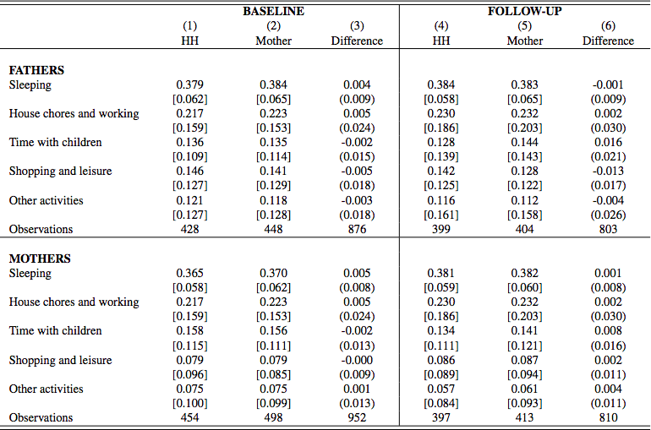

HH is an abbreviation for Household Heads, representing the control group. Mother represents the treatment group, in which mothers received the conditional cash transfers. The data is broken down into time use by Fathers and time use by Mothers. Each category is divided into subcategories denoting specific activities for which data was collected. Standard deviations are shown in brackets and standard errors in parenthesis.

Featured Evaluation: Armand, Alex, Orazio Attanasio, Pedro Carneiro, Valerie Lechene. 2016. “The Effect of Gender-Targeted Conditional Cash Transfers on Household Expenditures: Evidence from a Randomized Experiment.” Centre for Economic Policy Research IZA Discussion Paper No. 10133

Briefcase Author: Umang Bansal

RELATED PAPERS:

Attanasio, O. and V. Lechene (2010). “Conditional cash transfers, women and the demand for food”. *IFS working papers* (No. 10, 17)